EXPERIMENT-4

Janapati Venkata Sai Chandra Kousthubh

BU22CSEN0100682

# Q) UML DIAGRAMS OF ONLINE BANKING SERVICES

## USE CASE DIAGRAM

@startuml

left to right direction

actor Customer

actor BankEmployee

rectangle "Online Banking System" {

usecase "Register Account" as UC1

usecase "Login" as UC2

usecase "Check Account Balance" as UC3

usecase "Transfer Funds" as UC4

usecase "Pay Bills" as UC5

usecase "View Transaction History" as UC6

usecase "Apply for Loan" as UC7

usecase "Manage Beneficiaries" as UC8

usecase "Logout" as UC9

usecase "Approve Loan Application" as UC10

}

Customer -- UC1

Customer -- UC2

Customer -- UC3

Customer -- UC4

Customer -- UC5

Customer -- UC6

Customer -- UC7

Customer -- UC8

Customer -- UC9

BankEmployee -- UC10

UC7 ..> UC10 : "Requires Approval"

@enduml

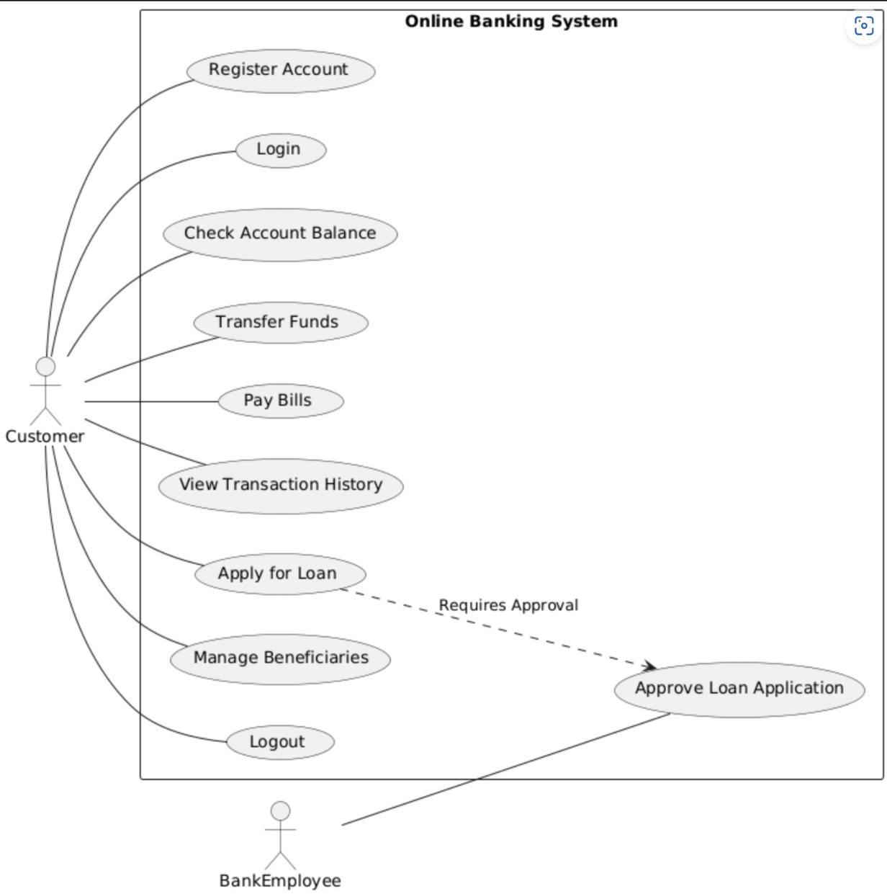

**CLASS DIAGRAM**

@startuml

class Customer { +registerAccount()

+login()

+checkBalance()

+transferFunds()

+payBills()

+viewTransactionHistory()

+applyForLoan()

+manageBeneficiaries()

+logout()

}

class BankEmployee { +approveLoanApplication()

}

class Account {

-accountNumber

-balance

+getBalance()

+updateBalance()

}

class Transaction {

-transactionId

-amount

-date

+getTransactionDetails()

}

class Loan {

-loanId

-amount

-interestRate

-status

+applyLoan()

+getLoanDetails()

}

Customer --> Account

Customer --> Transaction

Customer --> Loan

BankEmployee --> Loan : "approves"

@enduml

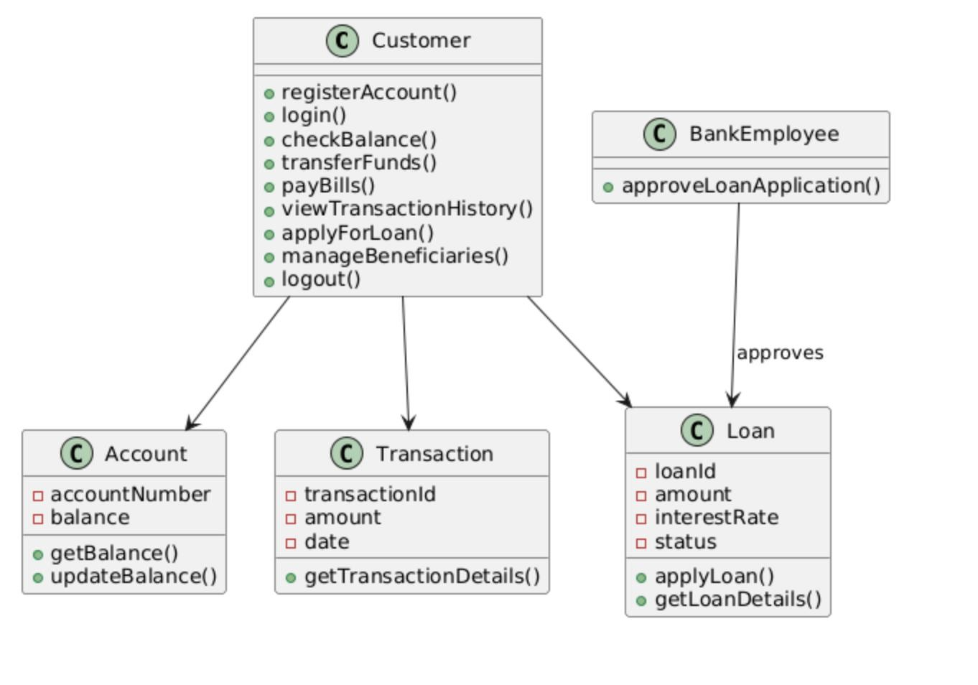

## SEQUENCE DIAGRAM

@startuml

actor Customer

participant "Online Banking System" as OBS

participant Account

participant Transaction

participant Loan

participant BankEmployee

Customer -> OBS: login()

OBS -> Account: verifyCredentials()

Account -> OBS: authenticationSuccess()

OBS -> Customer: loginSuccess()

Customer -> OBS: checkBalance()

OBS -> Account: getBalance()

Account -> OBS: returnBalance()

OBS -> Customer: displayBalance()

Customer -> OBS: transferFunds()

OBS -> Transaction: initiateTransfer()

Transaction -> Account: updateBalance()

Account -> Transaction: confirmTransaction()

Transaction -> OBS: transactionSuccess()

OBS -> Customer: transferSuccess()

Customer -> OBS: applyForLoan()

OBS -> Loan: processLoanApplication()

Loan -> BankEmployee: requestApproval()

BankEmployee -> Loan: approveLoan()

Loan -> OBS: loanApproved()

OBS -> Customer: notifyApproval()

Customer -> OBS: logout()

OBS -> Customer: logoutSuccess()

@enduml

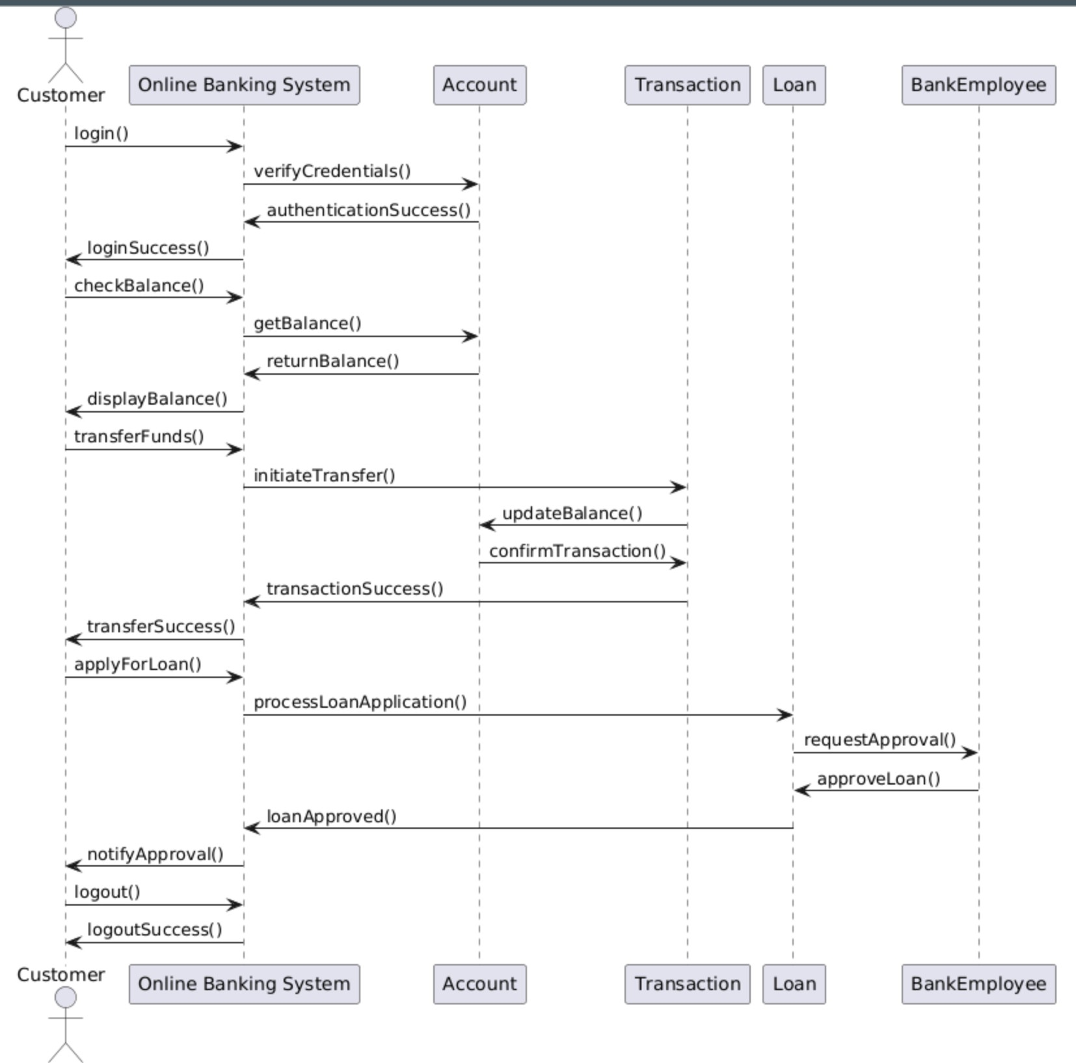

## COLLABORATION DIAGRAM

@startuml title Collaboration Diagram for Online Banking System

' Define objects in a vertical order

object Customer

object OnlineBankingSystem

object Account

object Transaction

object Loan

object BankEmployee

' Use top-to-bottom alignment for vertical layout

Customer -down-> OnlineBankingSystem : (1) login()

OnlineBankingSystem -down-> Account : (2) verifyCredentials()

Account -down-> OnlineBankingSystem : (3) authenticationSuccess()

OnlineBankingSystem -down-> Customer : (4) loginSuccess()

Customer -down-> OnlineBankingSystem : (5) checkBalance()

OnlineBankingSystem -down-> Account : (6) getBalance()

Account -down-> OnlineBankingSystem : (7) returnBalance()

OnlineBankingSystem -down-> Customer : (8) displayBalance()

Customer -down-> OnlineBankingSystem : (9) transferFunds()

OnlineBankingSystem -down-> Transaction : (10) initiateTransfer()

Transaction -down-> Account : (11) debitAmount()

Transaction -down-> Account : (12) creditAmount()

Transaction -down-> OnlineBankingSystem : (13) transactionSuccess()

OnlineBankingSystem -down-> Customer : (14) transferSuccess()

Customer -down-> OnlineBankingSystem : (15) applyForLoan()

OnlineBankingSystem -down-> Loan : (16) processLoanApplication()

Loan -down-> BankEmployee : (17) requestApproval()

BankEmployee -down-> Loan : (18) approveLoan()

Loan -down-> OnlineBankingSystem : (19) loanApproved()

OnlineBankingSystem -down-> Customer : (20) notifyApproval()

Customer -down-> OnlineBankingSystem : (21) logout()

OnlineBankingSystem -down-> Customer : (22) logoutSuccess()

@enduml

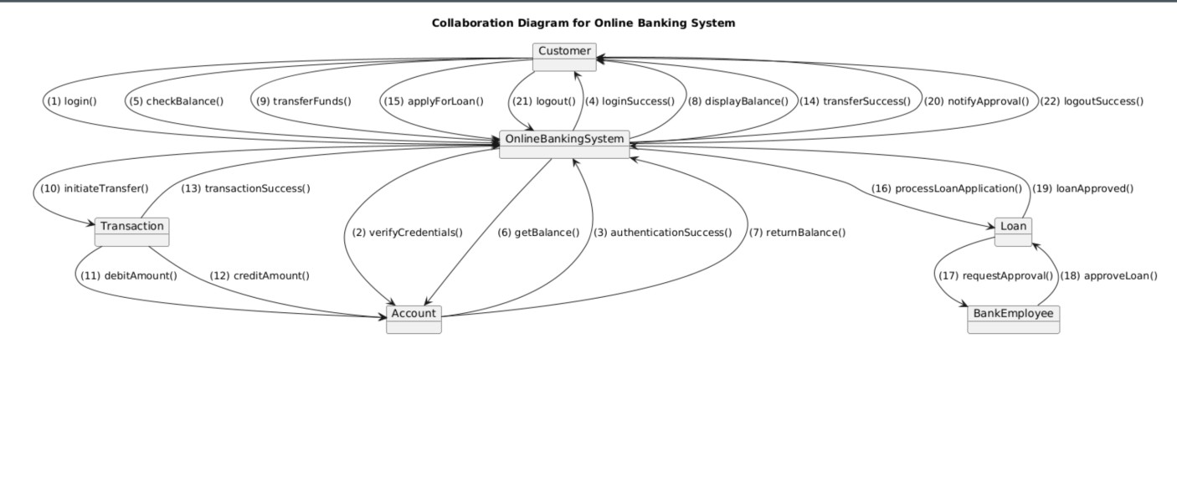

## STATE CHART DIAGRAM

@startuml

[*] --> Idle

Idle --> LoggingIn : Enter Credentials

LoggingIn --> LoggedIn : Authentication Successful

LoggingIn --> Idle : Authentication Failed

LoggedIn --> CheckingBalance : Check Balance

CheckingBalance --> LoggedIn : Balance Displayed

LoggedIn --> TransferringFunds : Transfer Funds

TransferringFunds --> TransactionCompleted : Transfer Successful

TransferringFunds --> LoggedIn : Transfer Failed

TransactionCompleted --> LoggedIn

LoggedIn --> ApplyingForLoan : Apply for Loan

ApplyingForLoan --> LoanApproved : Loan Approved

ApplyingForLoan --> LoanRejected : Loan Rejected

LoanApproved --> LoggedIn

LoanRejected --> LoggedIn

LoggedIn --> LoggingOut : Logout Request

LoggingOut --> Idle : Session Ended

@enduml

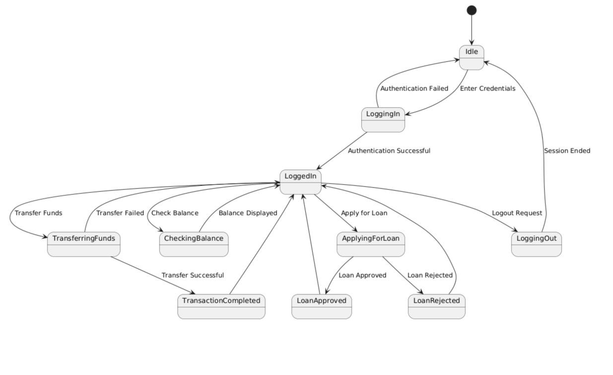

## ACTIVITY DIAGRAM

@startuml

start

:User Opens Online Banking Portal;

:Enter Credentials;

if (Are Credentials Valid?) then (Yes)

:Display Dashboard;

repeat

:Choose an Action;

switch (Selected Action)

case (Check Balance)

:Retrieve Account Balance;

:Display Balance;

case (Transfer Funds)

:Enter Transfer Details;

if (Is Transfer Valid?) then (Yes)

:Process Transfer;

:Transfer Successful;

else (No)

:Show Error Message;

endif

case (Apply for Loan)

:Submit Loan Application;

if (Loan Approved?) then (Yes)

:Approve Loan;

:Notify User;

else (No)

:Reject Loan;

:Notify User;

endif

endswitch

repeat while (User Wants Another Action?)

:Logout;

:End Session;

else (No)

:Show Login Error;

endif

stop

@enduml

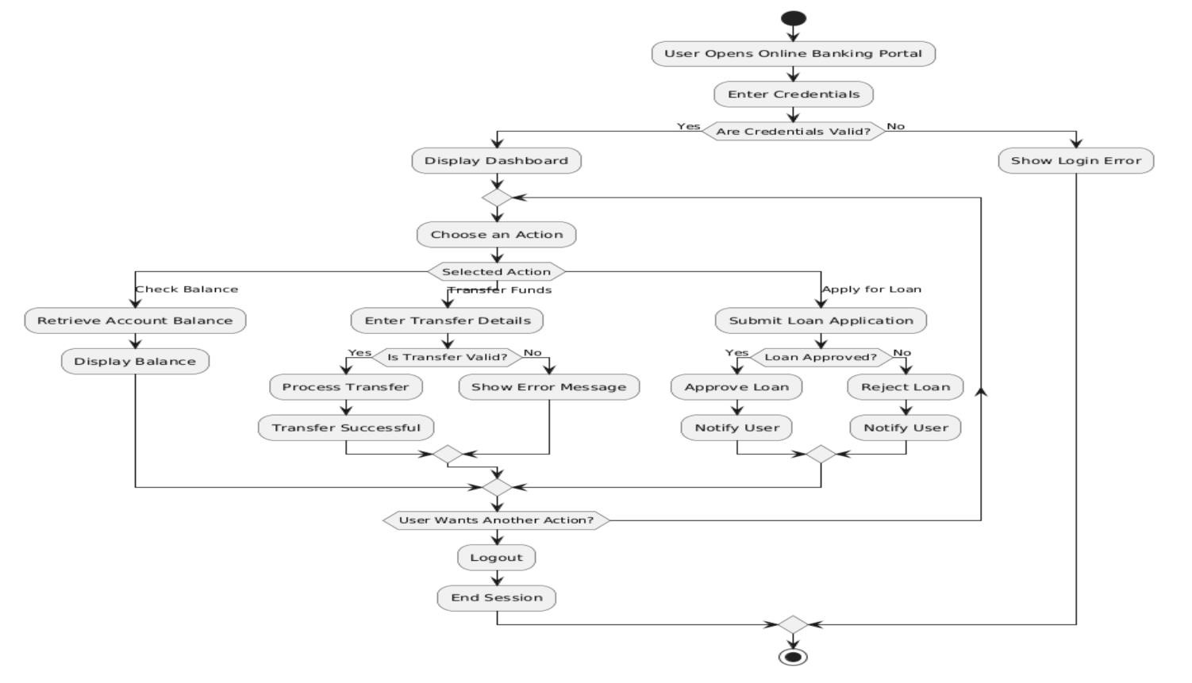

## COMPONENT DIAGRAM

@startuml

component "User Interface" as UI

component "Authentication Service" as Auth

component "Banking Services" as Banking

component "Transaction Service" as Transaction

component "Loan Processing" as Loan

component "Database" as DB

UI --> Auth : User Login

Auth --> DB : Verify Credentials

Auth --> UI : Authentication Success/Failure

UI --> Banking : Request Account Info

Banking --> DB : Fetch Account Details

Banking --> UI : Display Account Details

UI --> Transaction : Transfer Funds

Transaction --> Banking : Validate Funds

Transaction --> DB : Update Account Balance

Transaction --> UI : Show Transaction Status

UI --> Loan : Apply for Loan

Loan --> Banking : Check Eligibility

Loan --> DB : Store Loan Request

Loan --> UI : Loan Approval/Rejection

@enduml

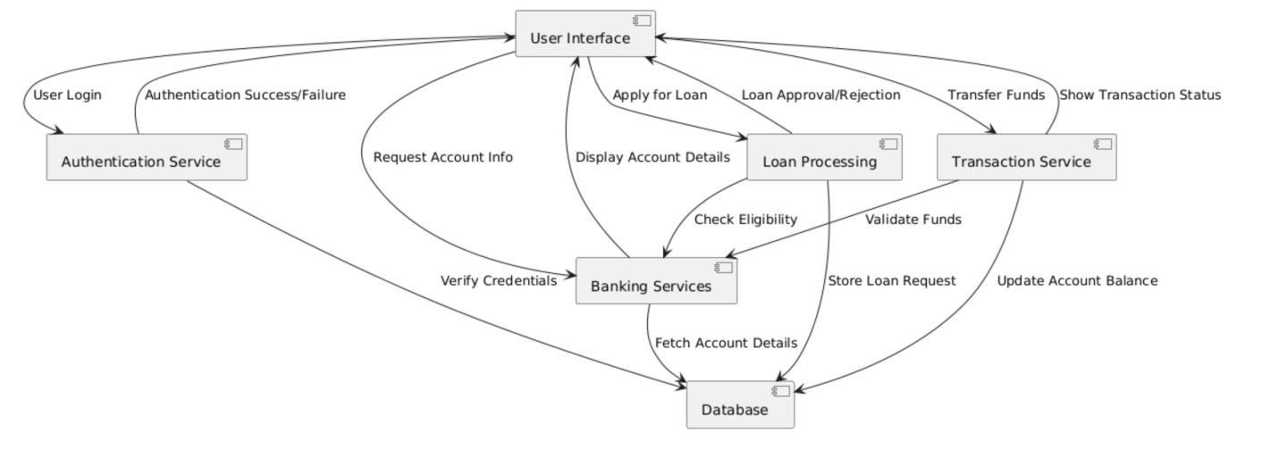

## DEPLOYMENT DIAGRAM

@startuml

node "User Device" {

component "Web Browser" as Browser

}

node "Bank Server" {

component "Web Server" as WebServer

component "Application Server" as AppServer

database "Banking Database" as DB

}

Browser --> WebServer : HTTP Request (Login, Transactions)

WebServer --> AppServer : Process Request

AppServer --> DB : Fetch/Update Data

DB --> AppServer : Send Response

AppServer --> WebServer : Send Processed Data

WebServer --> Browser : Display Result @enduml 